# **Overview**

* **About your team**
  + **Members and their roles –** name, student id, email, and role

1. **Baidildina Ayazhan - 204029,** [**204029@astanait.edu.kz**](mailto:204029@astanait.edu.kz)**, html, css, javascript, documentation was done**
2. **Basarov Bektas – 204086,** [**204086@astanait.edu.kz**](mailto:204086@astanait.edu.kz)**, html and express was done**
3. **Chshukina Karina – 204059,** [**204059@astanait.edu.kz**](mailto:204059@astanait.edu.kz)**, html and documentation was done**
4. **Dyusenbay Kazhybek – 204085,** [**204085@astanait.edu.kz**](mailto:204085@astanait.edu.kz)**, javascript and css was done**
5. **Otzhan Akhmed – 204100,** [**204100@astanait.edu.kz**](mailto:204100@astanait.edu.kz)**, html and documentation was done**
6. **Taszhanov Eskendir – 204050,** [**204050@astanait.edu.kz**](mailto:204050@astanait.edu.kz)**, express and javascript** 
   * **Communication strategy** –

We have group chat in telegram where we decide what everybody will do and share their ideas on improving the group work. In addition, we had face-to-face communication in order to

* **Motivation** –
* To understand all the ins and outs of passed discipline of WEB TECHNOLOGIES;
* To have communication with groupmates, and have good time;
* To improve knowledge of html, css, javascript, express, node.js, etc;
* That was a final project, due to this to have no retakes and have excellent marks.
* **High-level project scope** – It is brand-new website. Everything was done by our group members.
* **Target audience/market** – This website is useful tool for football fans, to have calculations of the game goals.

# **Project goals and team interests**

Project goals:

* To analyze the football games strategies and their possible outcomes.
* To provide calculator that can help football fans to understand risks of the game.
* To make assumptions on the game provided.

Team interests

* Understand HTML tags and CSS by building an football game goals website
* Set up a strong comprehension of web composition standards.
* Improve group working abilities by teaming up with various individuals from the gathering

# **Phases**

# Phase 1 – To understand the given task and divide works to the members.

* Phase 2 – To construct HTML, CSS files.
* Phase 3 – To make JavaScript, Node.js, Express, etc.
* Phase 4 – To fulfill and fix everything appropriately.
* Phase 5 – To write documentation.

# **Content structure**

*Site map:*

Here is provided diagram which shows the ‘tree’ type, hierarchical structure of the website page.

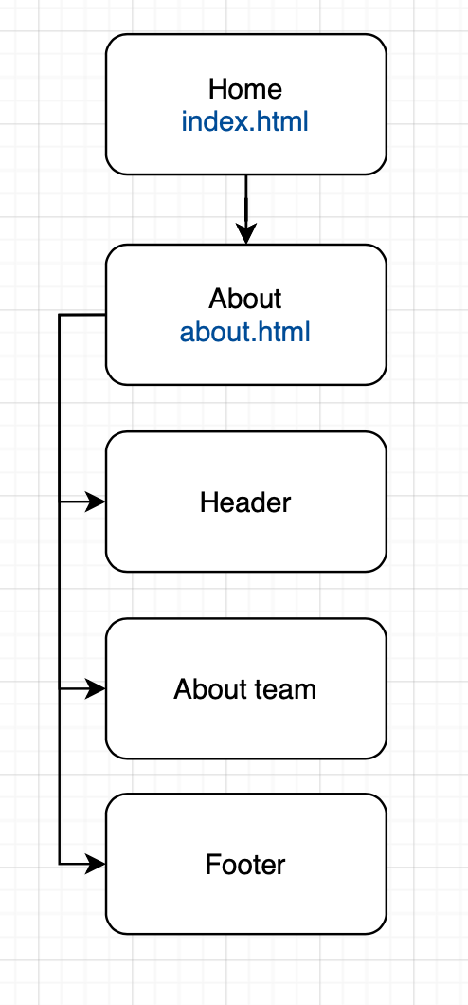

**Content types**

Since this is the website for football fans, it contains score calculator, information about football teams, that requires how many goals scored the teams and players of teams. There is a separate page for information about team. Contact information, all social networks contains in the footer of pages.

Main content types:

* Score calculator
* About team
* Contacts

**Design**

‘Home’ page:

Colors: white, grey, brown

Bootstrap

“About” page:

colors: white, grey, brown

Site includes a picture of our team

Spacing: breaking lines

Some of the website elements, such as: navbar are implemented by using Bootstrap (<https://getbootstrap.com>)

**Functionality**

This site is built according to web standards, has a well-programmed design in three colors, where the main one is light colors, which has a very positive effect on its perception and information content. it is better absorbed and understood by visitors. It is equally important that it works quickly and correctly, which helps to create a positive first impression.

**Hosting**

* create an empty folder.
* go to the created folder.
* install express.
* create a file.
* create a website in the folder (files:. html,. css, .js, etc.).
* start the server
* in the address bar of the browser, type: localhost:3000
* the site will start locally
* to generate the package.json file

**Accessibility**

The website can be opened on any device, as it is responsible.

We did not animate text and avoid making the letters flash or blink, so it will not cause any difficulties to read.

**Deadlines**

It’s still important to have an idea of the timescales involved, especially if there is a fixed deadline – an event, for example. If you have provided project phases, it is mandatory to provide it deadlines.

For example,

* Phase 1 – February 15.

On this day, we divided the responsibilities among ourselves and determined who performs what role in the construction of the website. After that, each subgroup started to work on their part of the task. We came up with a color scheme, selected the necessary fonts.

* Phase 2 – February 16.

We started working on the site. In this day was made homepage, header, footer, about page. We did HTML, CSS codes.

* Phase 3 – February 17.

We did JavaScript, node.js, express, json.

* Phase 4 – February 18.

The website has acquired a final appearance, the final touches have been done, and all errors have been fixed.

# **Summary**

After completing the creation of this site, we have achieved all our goals and team interests that we were aimed for. Teamwork brings us a lot of interesting and useful things. We improve our HTML, CSS, JavaScript, and etc. skills. During the time that we worked on the project, our team members were positive mood and our work was always carried out in a kind, pleasant atmosphere. All the work was done in accordance with the given theme, the most calm colors were chosen without distraction and convenient readable fonts. At the end of this project, we improved our skills and since there was not much time, we had to work as quickly as possible and we got out of our comfort zone.